ASSIGNMENT SUBMISSION COVER SHEET
Student ID:

Student names:

Student email:

Cohort:
Assignment title:

Date of submission:
Programme of Study:
Year of Study:

Intellectual property statement
By checking the box below, I certify that this assignment is my own work and is free from plagiarism. I understand that the assignment may be checked for plagiarism by electronic or other means and may be transferred and stored in a database for the purposes of data-matching to help detect plagiarism. The assignment has not previously been submitted for assessment in any other unit or to any other institution.
I have read and understood the Botswana Accountancy College plagiarism guidelines policy.

☐ Agree Signature…………………………………
Date…....…20/04/2026…………+

- Website Specifications:
- This website is all about being a professional portfolio to help DJs land paid gigs. It focuses on building trust and showing off each DJ's unique sound and performance style with mixes and media. Plus, it makes it super easy for promoters and clients to get in touch and book the DJs. Basically, it helps turn visitors into booking inquiries while also boosting the DJs' brands.
- This website is mainly for two groups. First, we have promoters and event organizers, who are good with technology. They want clear and organized info like press kits and booking details to ensure everything looks reliable. On the other hand, there are fans and regular users who might not be as tech-focused. They’re looking for a mobile-friendly site with quick audio and visuals that really capture the DJ’s vibe.
- This website is all about promoting a business and showing off its portfolio. It's got multimedia stuff like photos and shares key information that meets technical standards. Plus, there are handy features like a booking form and an event calendar to make things super convenient for users.
- Information Design & Taxonomy:
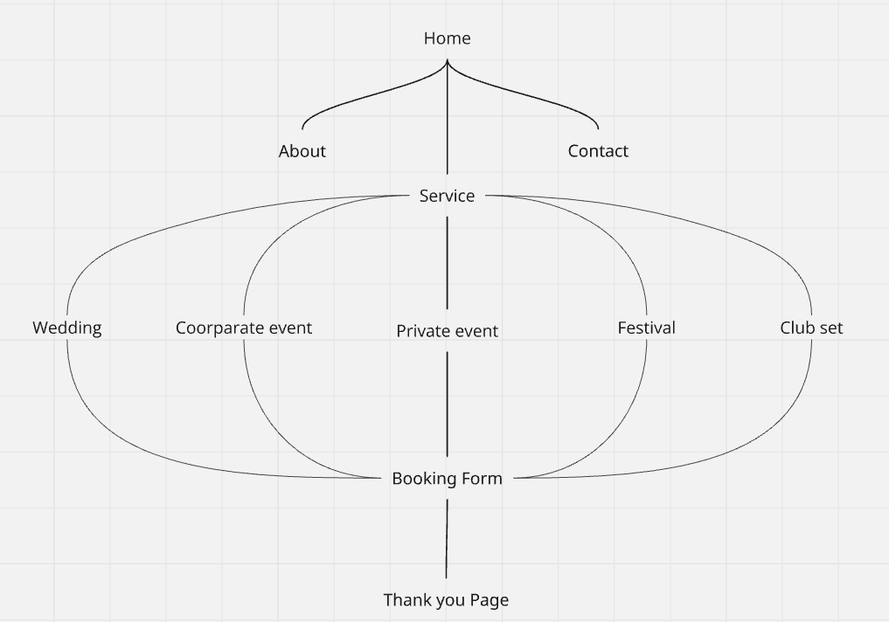
- Home
- It provides the first impression to the users.
- About
- It explains the reason and the purpose of the website.
- Service
- Shows what the DJs are offering
- Contact
- Primary conversion point
- Booking form + Thank You
- Handle the transaction
- Page Template Design
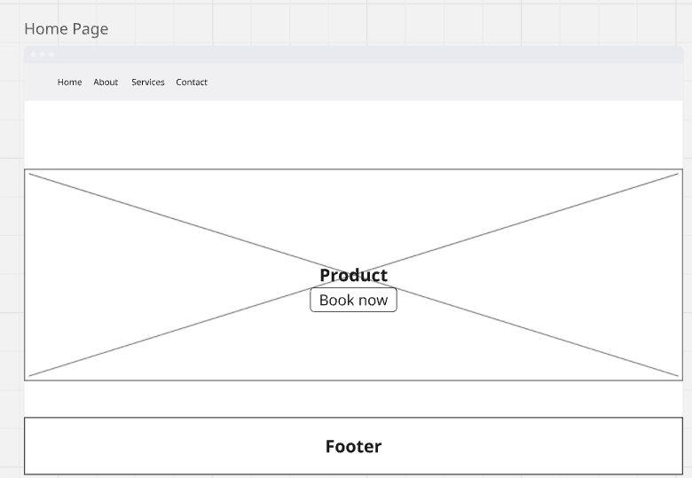
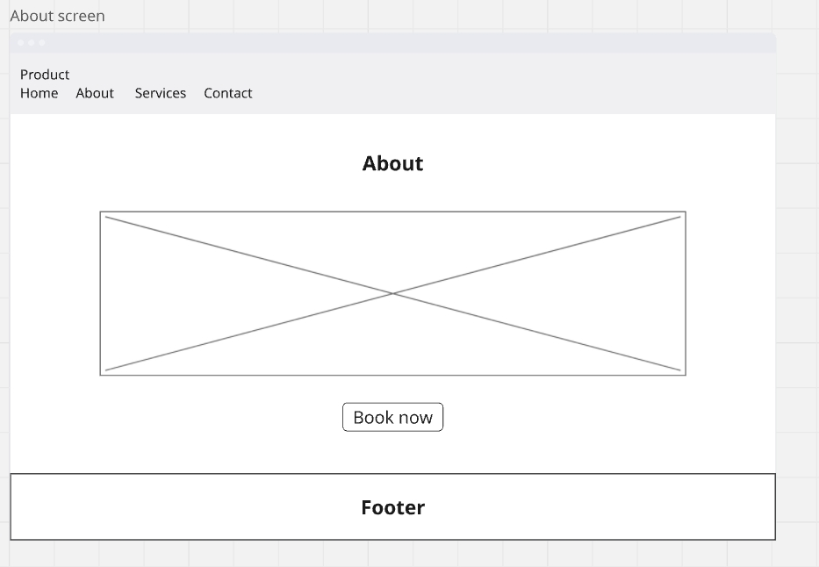

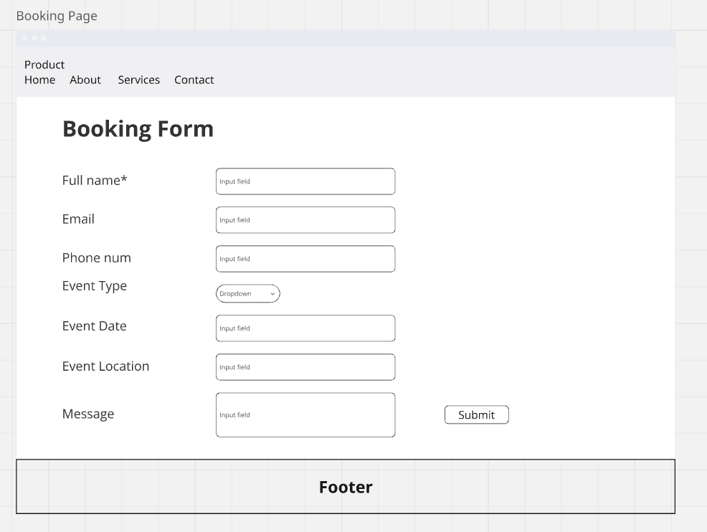

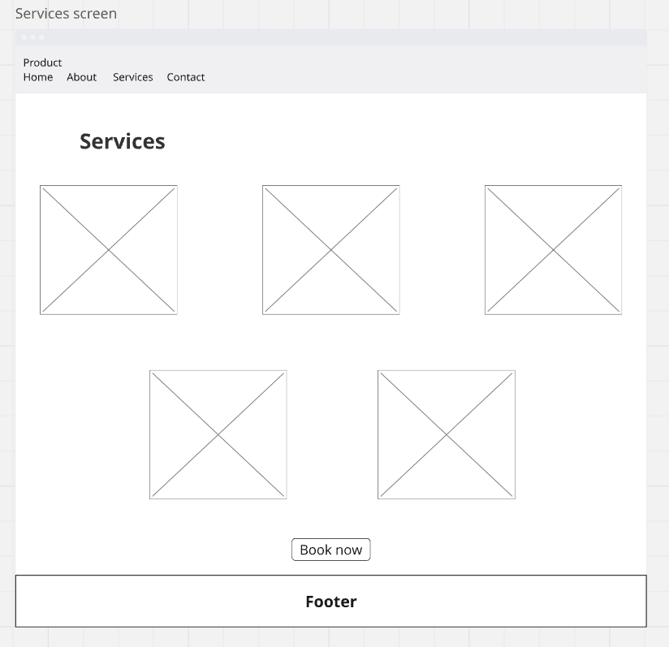

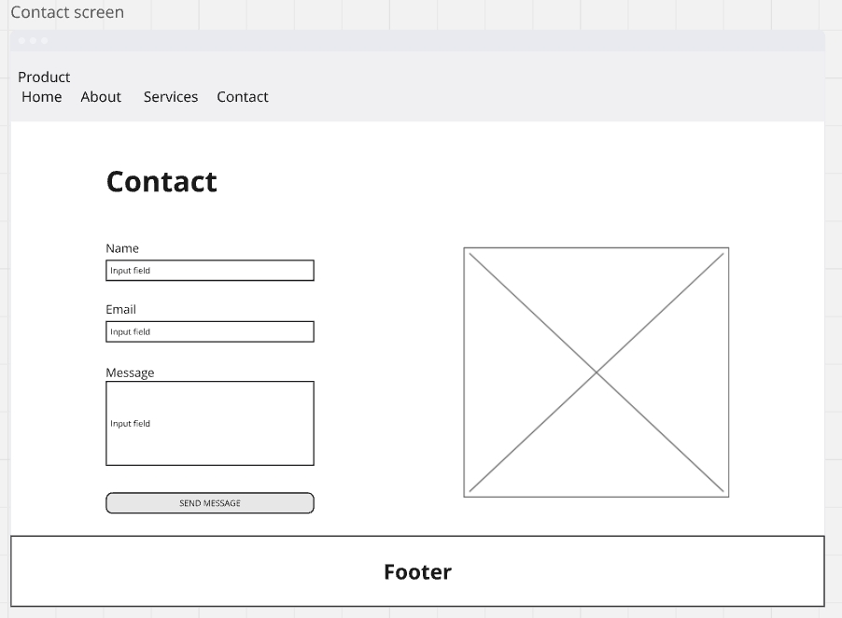
- Structural Layer – HTML 5
Home Page
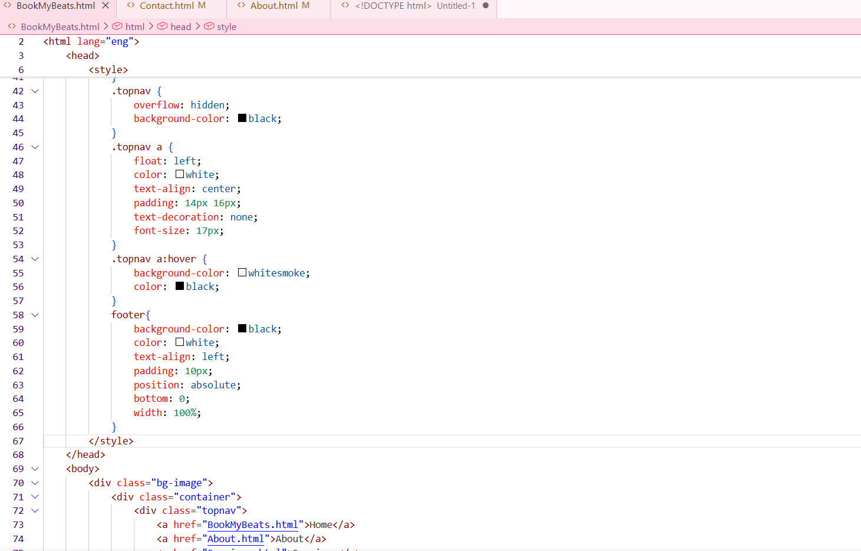
About Page
